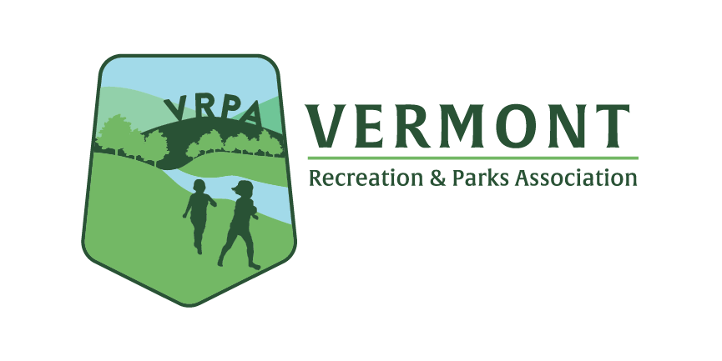
Vermont State Pickleball Championship Tournament 2024

Supporting SPONSORSHIP OPPORTUNITIES:

Sponsor Levels | Smash - $1,500 | Rally – $1,000 | Drop Shot - $500 | Pickle - $250
Vendor Table

Display signage at tournament venue (sponsor must provide signage)

Public recognition during the tournament

Logo on printed promotional materials

Business Name or logo on printed event t-shirts

Logo and business name posted on all social media promotions

Event Underwriting SPONSORSHIP OPPORTUNITIES:

Coffee & Welcoming Sponsor $200 (includes logo & welcome materials at registration & coffee table)

Lunch Sponsor $500 (includes digital Ad, logo in print & verbal mention at lunch welcoming)

Gift Sponsor $1,000 (includes exclusive logo on gifts handed out to competitors)

Facility Sponsor $2,000 (or use of your facility to host the tournament – includes signage & recognition in marketing prior to the tournament)

Thank you in advance for your support!!

Vermont Recreation & Parks Association

