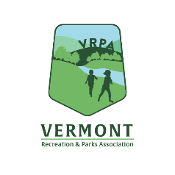
Vermont Recreation and Parks Association

2023 ADVERTISING RATES
VRPA ADVOCATE, Weekly Emails, & Website

Contact: ____________________________________Company: _____________________________________

Address: ___________________________________________________________

City: ___________________________ State: _________ ZIP: _______________

Phone: _____________________ FAX: ______________________ Email: _________________________________

VRPA Advocate Annual Newsletter: We wish to place the following ads:

Issue Size Member Non-Member

January 2023 __1/8 Page (2.37” x 3.62”) (or business card) __$50 __$75
__1/4 Page (3.67” x 4.85”) __$75 __$100
__1/2 Page (7.5” x 4.85”) __$125 __$230
__Full page (7.5” x 10.0”) __$200 __$340
Total Newsletter Cost $_________ $_________

Social Media Package:
1 Month = 4 social media posts ($125) $ _________ $ ________

VRPA Website: $125 per month (members). $ _________ $ _________
Month requested(s): ___________________________________________

VRPA Rec Check-In Emails: $150 per month (members). $ _________ $ _________
Month requested(s): ___________________________________________

One-Year Commercial Membership (1 staff member) $ 205.00

TOTAL $_________ $_________

___ An electronic camera ready ad has been emailed to Jessica@vrpa.org. We can make arrangements to have
your ad typeset but there will an additional charge.

___ Check No. __________ payable to VRPA for the total amount due is enclosed.

Mail to: VRPA, P.O. Box 33, Brownsville, VT 05037. Phone: 774-254-0071, Email: Jessica@vrpa.org

-

